LAB: Cellular Respiration and Muscle Fatigue
GPS S7L2 a, b, c, d

Background Information: Just as an automobile must be supplied with gasoline as a source of energy before it can move, so too your muscles require energy in order to contract. This energy, in the form of ATP, can be produced with oxygen (this is called aerobic respiration) or without oxygen (this is called anaerobic respiration). In animal cells the anaerobic process is called Lactic Acid Fermentation, and it occurs when there isn't any oxygen available in the cells for aerobic respiration. This buildup of lactic acid, as a product of this anaerobic respiration, reaches a point where the muscles have a reduced ability to contract, until eventually exhaustion sets in and contraction of the muscle will stop. This is muscle fatigue. Similarly, in the case of the automobile when the waste products (exhaust) cannot be removed and build up inside the engine, the automobile will stop.

Purpose: In this activity students will investigate cellular respiration, and the factors that affect skeletal muscle fatigue.
Materials:
- Clothes pins
- Timer
- Lab sheet
- Pencil/pen

Objectives:
- To observe skeletal muscle fatigue.
- To explain the relationship between muscle fatigue, cellular respiration and ATP production.
- To chart and interpret the results obtained.

Research Question: After how many trials of testing will hand skeletal muscle experience fatigue?

Hypothesis: (Hypothesize in an if-then-because format)
______________________________________________________________________________________________________________________________________________________________________________________________________________________________________________________________________________________________________________________________________________________________________________________________________

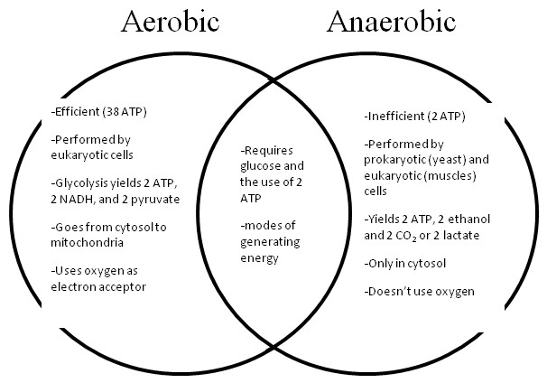
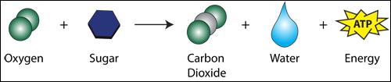
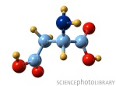
Pre-Lab Questions: Study the Venn diagram below. Then, answer the questions that follow. Use complete sentences when necessary.
Lactic Acid

Fermentation
Cellular Respiration

- Describe a situation, which you have experienced, when you felt like you were unable to sustain or maintain a steady supply of oxygen to your muscles. In other words you got muscle cramps or felt fatigued.

- Write the chemical reaction for aerobic respiration and anaerobic respiration. Use chemical formulas. Names are written in the parentheses for you.
Aerobic Respiration:

_________________ + _______ _________ + __________ + ____________
( glucose) (oxygen) (water) (carbon dioxide) (adenosine triphosphate)

Anaerobic Respiration:

_________________ _______________ + _________________ + _______________
( glucose) (carbon dioxide) (lactic acid) (adenosine triphosphate)

- Which process is more efficient at producing ATP? Express in terms of a ratio.
Aerobic Respiration | Anaerobic Respiration
1 molecule glucose: ______ ATP | 1 molecule glucose: ______ ATP

- Looking back at the equations from #2, infer how the reactants are delivered to the cell?

Procedures:
- Hold a clothes pin in the thumb and index finger of the dominant hand and open and close it while the other fingers of the hand are held out straight. Record the number of times the clothes pin opens and closes to its maximum distance in 30 seconds in the data table. Students should attempt to squeeze quickly and completely, to get the maximum number of squeezes for each trial.
- Repeat this process for nine more 30 second trials recording the result for each trial. Do not rest the fingers between trials. You should have 10 trails completed when done.
- Repeat steps 1 and 2 for the non-dominant hand. Record all data in the table below.
- After you have collected the data, prepare a line graph of the data you collected. There is a graph on the next page. The trial number is the independent variable (x-axis) and the number of squeezes is the dependent variable (y-axis). Use two lines, one for the dominant hand and one for the non-dominant hand. Make sure to label your axes clearly and give your graph a clear, detailed title.

Data:

Trail # | # of Squeezes in 30 sec  Dominant Hand | # of Squeezes in 30 sec  Non-Dominant Hand
1
2
3
4
5
6
7
8
9
10

Title: _________________________________________________________________________

Key:

Analysis: (Answer the following questions using complete sentences and vocabulary terms)
- What happened to your “strength” as you progressed through each trial? How does your line graph support your answer?
- What physiological factors do you suggest caused you to get more or less squeezes, in other words, what caused or did not cause fatigue?

- Explain how your results would have differed had you waited 10 minutes in between each trial.

- Which product of anaerobic respiration caused your cells to be less efficient? In contrast, which reactant or lack thereof caused your cells to be less efficient?

- What is the relationship between the presence of oxygen and the production of ATP in muscle cells?

- What is the relationship between the number of mitochondria found in a cell and the type of cell? Which cell type(s) would require more mitochondria? Explain your reasoning.

Conclusion: Use the conclusion graphic organizer to write a 1-2 paragraph conclusion. Fill-in your responses in the third column. Once the graphic organizer is complete use it to write your conclusion in paragraph form.

Required Element | Response begins with… | Your response…
Restate the question | The question investigated in this experiment was….
Restate the hypothesis | It was hypothesized that….
Was the hypothesis correct or incorrect? | The results of this experiment proved that my hypothesis was…… because…..
State the conclusion (what was the answer to the purpose?) | The purpose of the investigation was to determine…
Support your conclusion with specific data (refer to numbers in your tables and graphs) | The data demonstrates that…
Give at least 2 supporting statements about the validity of your results (were their any errors? things that went wrong?) | The results may not be valid because…. | 1.  2.
Give at least 2 statements about how to improve the experiment (what could you do differently?) | When performing this experiment again, it will be important to …. | 1.  2.
Give examples that relate to real life and/or to the chapter | These results are related to ……. because…..
Use the space on the next page to write your conclusion.

____________________________________________________________________________________________________________________________________________________________________________________________________________________________________________________________________________________________________________________________________________________________________________________________________________________________________________________________________________________________________________________________________________________________________________________________________________________________________________________________________________________________________________________________________________________________________________________________________________________________________________________________________________________________________________________________________________________________________________________________________________________________________________________________________________________________________________________________________________________________________________________________________________________________________________________________________________________________________________________________________________________________________________________________________________________________________________________________________________________________________________________________________________________________________________________________________________________________________________________________________________________________________________________________________________________________________________________________________________________________________________________________________________________________________________________________________________________________________________________________________________________________________________________________________________________________________________________________________________________________________________________________________________________________________________________________________________________________________________________________________________________________________________________________________________________________________________________________________________________________________________________________________________________________________________________________________________________________________________________________________________________________________________________________________________________________________________________________________________________________________________________________________________________________________________________________________________________________________________________________________________________________________________________________________________________________________________________________________________________________________________________________________________________________________________________________________________________________________________________________________________________________________________________________________________________________________________________________________________________________________________________________________________________________________________________________________________________________________________________________________________________________________________________________________

